**MSX slot connector for Raspberry Pi 2**

2016.02.08 [meeso.kim@gmail.com](mailto:meeso.kim@gmail.com)

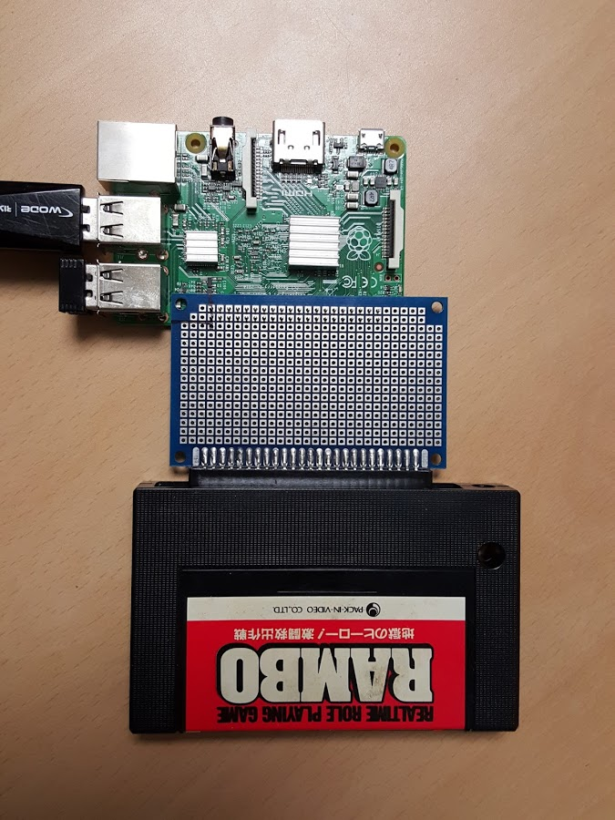

|  |  |  |  |  |  |  |  |
| --- | --- | --- | --- | --- | --- | --- | --- |
| No | Mapping | I/O | PIN | No | Mapping | I/O | PIN |
| 0 | RST | O | 27 | 16 | CS12 | O | 36 |
| 1 | WAIT | I | 28 | 17 | IORQ | O | 11 |
| 2 | CLK | O | 3 | 18 | CS2 | O | 12 |
| 3 | WR | O | 5 | 19 | D0 | I | 35 |
| 4 | RD | O | 7 | 20 | D1 | I | 38 |
| 5 | BUSDIR | I | 29 | 21 | D2 | I | 40 |
| 6 | INT | I | 31 | 22 | D3 | I | 15 |
| 7 | X (CE1) | x | 26 | 23 | D4 | I | 16 |
| 8 | **CE0** | O | 24 | 24 | D5 | I | 18 |
| 9 | X (MISO) | I | 21 | 25 | D6 | I | 22 |
| 10 | **MOSI** | O | 19 | 26 | D7 | I | 37 |
| 11 | **SCLK** | O | 23 | 27 | MERQ | O | 13 |
| 12 | SLTSL | O | 32 | 28 |  |  |  |
| 13 | CS1 | O | 33 | 29 |  |  |  |
| 14 | **TX** | O | 8 | 30 |  |  |  |
| 15 | **RX** | I | 10 | 31 |  |  |  |

Front Pinout

|  |  |  |  |  |  |  |  |  |  |  |  |
| --- | --- | --- | --- | --- | --- | --- | --- | --- | --- | --- | --- |
|  |  |  |  |  |  |  |  |  | Front | Back |  |
| 3V3 | 1 | 2 | 5V | x | 9 | 8 | GND | -12V | 50 | 49 | SND |
| CLK | 3 | 4 | 5V | 3V3 | 10 | 7 | MD7 | +12V | 48 | 47 | 5V |
| WR | 5 | 6 | GND | SCLK | 11 | 6 | MD6 | SW2 | 46 | 45 | 5V |
| RD | 7 | 8 | TXD | CE0 | 12 | 5 | MD5 | SW1 | 44 | 43 | GND |
| GND | 9 | 10 | RXD | WR | 13 | 4 | MD4 | CLK | 42 | 41 | GND |
| IORQ | 11 | 12 | CS2 | **1Q7** | 14 | 3 | MD3 | MD6 | 40 | 39 | MD7 |
| MERQ | 13 | 14 | GND | MD0 | 15 | 2 | MD2 | MD4 | 38 | 37 | MD5 |
| D3 | 15 | 16 | D4 | 3V3 | 16 | 1 | MD1 | MD2 | 36 | 35 | MD3 |
| 3V3 | 17 | 18 | D5 | **0Q7** | 9 | 8 | GND | MD0 | 34 | 33 | MD1 |
| MOSI | 19 | 20 | GND | 3V3 | 10 | 7 | MA07 | MA04 | 32 | 31 | MA05 |
| MISO | 21 | 22 | D6 | SCLK | 11 | 6 | MA06 | MA02 | 30 | 29 | MA03 |
| SCLK | 23 | 24 | CE0 | CE0 | 12 | 5 | MA05 | MA00 | 28 | 27 | MA01 |
| GND | 25 | 26 | x | GND | 13 | 4 | MA04 | MA13 | 26 | 25 | MA14 |
| RST | 27 | 28 | WAIT | **MOSI** | 14 | 3 | MA03 | MA08 | 24 | 23 | MA12 |
| BUSDIR | 29 | 30 | GND | MA00 | 15 | 2 | MA02 | MA06 | 22 | 21 | MA07 |
| INT | 31 | 32 | SLTSL | 3V3 | 16 | 1 | MA01 | MA10 | 20 | 19 | MA11 |
| CS1 | 33 | 34 | GND | **1Q7** | 9 | 8 | GND | MA15 | 18 | 17 | MA09 |
| D0 | 35 | 36 | CS12 | 3V3 | 10 | 7 | MA15 | N.C | 16 | 15 | **RST** |
| D7 | 37 | 38 | D1 | SCLK | 11 | 6 | MA14 | RD | 14 | 13 | WR |
| GND | 39 | 40 | D2 | CE0 | 12 | 5 | MA13 | MERQ | 12 | 11 | IORQ |
|  |  |  |  | GND | 13 | 4 | MA12 | **BUSDIR** | 10 | 9 | M1 |
|  |  |  |  | **0Q7** | 14 | 3 | MA11 | **INT** | 8 | 7 | **WAIT** |
|  |  |  |  | MA08 | 15 | 2 | MA10 | RFSH | 6 | 5 | N.C |
|  |  |  |  | 3V3 | 16 | 1 | MA09 | SLTSL | 4 | 3 | CS12 |
|  |  |  |  |  |  |  |  | CS2 | 2 | 1 | CS1 |

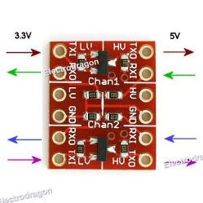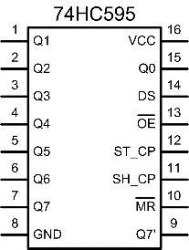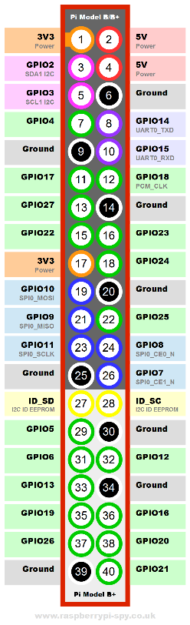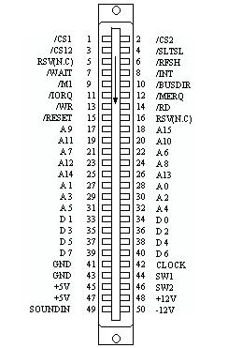



**Back Pinout**

|  |  |  |  |  |  |  |  |  |  |  |  |
| --- | --- | --- | --- | --- | --- | --- | --- | --- | --- | --- | --- |
|  |  |  |  |  |  |  |  |  | Front | Back |  |
|  |  |  |  |  |  |  |  | CS2 | 2 | 1 | CS1 |
|  |  |  |  | 3V3 | 16 | 1 | MA09 | SLTSL | 4 | 3 | CS12 |
|  |  |  |  | MA08 | 15 | 2 | MA10 | RFSH | 6 | 5 | N.C |
|  |  |  |  | **0Q7** | 14 | 3 | MA11 | **INT** | 8 | 7 | **WAIT** |
|  |  |  |  | GND | 13 | 4 | MA12 | **BUSDIR** | 10 | 9 | M1 |
| GND | 39 | 40 | D2 | CE0 | 12 | 5 | MA13 | MERQ | 12 | 11 | IORQ |
| D7 | 37 | 38 | D1 | SCLK | 11 | 6 | MA14 | RD | 14 | 13 | WR |
| D0 | 35 | 36 | CS12 | 3V3 | 10 | 7 | MA15 | N.C | 16 | 15 | **RST** |
| CS1 | 33 | 34 | GND | **1Q7** | 9 | 8 | GND | MA15 | 18 | 17 | MA09 |
| INT | 31 | 32 | SLTSL | 3V3 | 16 | 1 | MA01 | MA10 | 20 | 19 | MA11 |
| BUSDIR | 29 | 30 | GND | MA00 | 15 | 2 | MA02 | MA06 | 22 | 21 | MA07 |
| RST | 27 | 28 | WAIT | **MOSI** | 14 | 3 | MA03 | MA08 | 24 | 23 | MA12 |
| GND | 25 | 26 | x | GND | 13 | 4 | MA04 | MA13 | 26 | 25 | MA14 |
| SCLK | 23 | 24 | CE0 | CE0 | 12 | 5 | MA05 | MA00 | 28 | 27 | MA01 |
| MISO | 21 | 22 | D6 | SCLK | 11 | 6 | MA06 | MA02 | 30 | 29 | MA03 |
| MOSI | 19 | 20 | GND | 3V3 | 10 | 7 | MA07 | MA04 | 32 | 31 | MA05 |
| 3V3 | 17 | 18 | D5 | **0Q7** | 9 | 8 | GND | MD0 | 34 | 33 | MD1 |
| D3 | 15 | 16 | D4 | 3V3 | 16 | 1 | MD1 | MD2 | 36 | 35 | MD3 |
| MERQ | 13 | 14 | GND | MD0 | 15 | 2 | MD2 | MD4 | 38 | 37 | MD5 |
| IORQ | 11 | 12 | CS2 | **1Q7** | 14 | 3 | MD3 | MD6 | 40 | 39 | MD7 |
| GND | 9 | 10 | RXD | WR | 13 | 4 | MD4 | CLK | 42 | 41 | GND |
| RD | 7 | 8 | TXD | CE0 | 12 | 5 | MD5 | SW1 | 44 | 43 | GND |
| WR | 5 | 6 | GND | SCLK | 11 | 6 | MD6 | SW2 | 46 | 45 | 5V |
| CLK | 3 | 4 | 5V | 3V3 | 10 | 7 | MD7 | +12V | 48 | 47 | 5V |
| 3V3 | 1 | 2 | 5V | x | 9 | 8 | GND | -12V | 50 | 49 | SND |

|  |  |  |  |  |  |  |  |
| --- | --- | --- | --- | --- | --- | --- | --- |
| No | Mapping | I/O | PIN | No | Mapping | I/O | PIN |
| 0 | RST | O | 27 | 16 | CS12 | O | 36 |
| 1 | WAIT | I | 28 | 17 | IORQ | O | 11 |
| 2 | CLK | O | 3 | 18 | CS2 | O | 12 |
| 3 | WR | O | 5 | 19 | D0 | I | 35 |
| 4 | RD | O | 7 | 20 | D1 | I | 38 |
| 5 | BUSDIR | I | 29 | 21 | D2 | I | 40 |
| 6 | INT | I | 31 | 22 | D3 | I | 15 |
| 7 | X (CE1) | x | 26 | 23 | D4 | I | 16 |
| 8 | **CE0** | O | 24 | 24 | D5 | I | 18 |
| 9 | X (MISO) | I | 21 | 25 | D6 | I | 22 |
| 10 | **MOSI** | O | 19 | 26 | D7 | I | 37 |
| 11 | **SCLK** | O | 23 | 27 | MERQ | O | 13 |
| 12 | SLTSL | O | 32 | 28 |  |  |  |
| 13 | CS1 | O | 33 | 29 |  |  |  |
| 14 | **TX** | O | 8 | 30 |  |  |  |
| 15 | **RX** | I | 10 | 31 |  |  |  |

**MSX Slot Pin Map**

|  |  |  |  |
| --- | --- | --- | --- |
| **Pin** | **Name** | **Dir** | **Description** |
| 1 | /CS1 | --> | Memory Read in addresses 4000~7FFF |
| 2 | /CS2 | --> | Memory Read in addresses 8000~BFFF |
| 3 | /CS12 | --> | Memory Read in addresses 4000~BFFF |
| 4 | /SLTSL | --> | Low when Slot 2 (cartridge slot) is selected |
| 5 | N/C | N/A | Not Connected. |
| 6 | /RFSH | --> | Refresh signal from CPU |
| 7 | /WAIT | <-- | OC, Tells CPU to wait. Refresh signal is not maintained |
| 8 | /INT | <-- | OC, Requests a interrupt to CPU (call to addr 38h) |
| 9 | /M1 | --> | CPU fetches first part of instruction from memory. |
| 10 | /BUSDIR | <-- | NC, was used to control the data direction. |
| 11 | /IORQ | --> | I/O request signal. (Address=Port) |
| 12 | /MREQ | --> | Memory request signal. (Address=Address) |
| 13 | /WR | --> | Write signal (strobe) |
| 14 | /RD | --> | Read signal (strobe) |
| 15 | /RESET | <-- | Reset |
| 16 | n/c | - | Not connected. |
| 17 | A9 | --> | Address 9 |
| 18 | A15 | --> | Address 15 |
| 19 | A11 | --> | Address 11 |
| 20 | A10 | --> | Address 10 |
| 21 | A7 | --> | Address 7 |
| 22 | A6 | --> | Address 6 |
| 23 | A12 | --> | Address 12 |
| 24 | A8 | --> | Address 8 |
| 25 | A14 | --> | Address 14 |
| 26 | A13 | --> | Address 13 |
| 27 | A1 | --> | Address 1 |
| 28 | A0 | --> | Address 0 |
| 29 | A3 | --> | Address 3 |
| 30 | A2 | --> | Address 2 |
| 31 | A5 | --> | Address 5 |
| 32 | A4 | --> | Address 4 |
| 33 | D1 | <-> | Data 1 |
| 34 | D0 | <-> | Data 0 |
| 35 | D3 | <-> | Data 3 |
| 36 | D2 | <-> | Data 2 |
| 37 | D5 | <-> | Data 5 |
| 38 | D4 | <-> | Data 4 |
| 39 | D7 | <-> | Data 7 |
| 40 | D6 | <-> | Data 6 |
| 41 | GND | --- | Ground |
| 42 | CLOCK | --> | CPU clock, 3.579545MHz |
| 43 | GND | --- | Ground |
| 44 | SW1 | - | Insert/remove detection for protection |
| 45 | +5V | --> | +5 VDC (300mA max/Slot) |
| 46 | SW2 | - | Insert/remove detection for protection |
| 47 | +5V | --> | +5 VDC (300mA max/Slot) |
| 48 | +12V | --> | +12 VDC (50mA max/Slot) |
| 49 | SOUNDIN | <-- | Sound input (-5dBm) |
| 50 | -12V | --> | -12 VDC (50mA max/Slot) |

**1**